CASE STUDY 2: Traffic Flow and Velocity Estimation
Scenario
A traffic monitoring system records the position of a vehicle every second. Engineers want to compute velocity and total distance traveled.
Computational Task
Students must:
• Estimate instantaneous velocity
• Compute total distance
• Analyze traffic behavior

Given Data
Time(s) | Position(m)
0 | 0
1 | 5
2 | 15
3 | 30
4 | 50
5 | 75

Steps:
Velocity Table
Time(s) | Velocity(m/s)
1 | 7.5 m/s
2 | 12.5 m/s
3 | 17.5 m/s
4 | 22.5 m/s

- Velocity Estimation:
- Use central difference:
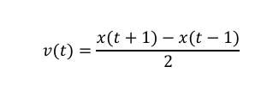

Compute Velocities:
t=1
$v\left(1\right)=\frac{x\left(2\right)-x\left(0\right)}{2}$ = $\frac{15-0}{2}$ = 7.5 m/s
t=2
v(2) $=\frac{30-5}{2}=\frac{25}{2}=12.5\frac{m}{s}$

t=3 $v\left(3\right)=\frac{50-15}{2}=\frac{35}{2}=17.5\frac{m}{s}$

t=4 $v\left(4\right)=\frac{75-30}{2}=\frac{45}{2}=22.5\frac{m}{s}$

- Acceleration Insight
$$a\left(t\right)=\frac{v\left(t+1\right)-v\left(t-1\right)}{2}$$

$$a\left(2\right)=\frac{17.5-7.5}{2}=\frac{10}{2}=5{\frac{m}{s^{2}}}^{}$$

$$a\left(3\right)=\frac{22.5-7.5}{2}=\frac{10}{2}=\frac{5m}{s^{2}}$$

Acceleration is constant at 5m/s²

- Distance Verification (Total Distance)
- Use Trapezoidal Rule to compute

∫𝑣(𝑡) 𝑑𝑡
Using Trapezoidal Rule: $\frac{h}{2}$[v0 + 2v1 + 2v2 + 2v3 +2v4 + v5]
(where h = 1)
= $\frac{1}{2}$[5 + 2(7.5)+ 2(12.5) + 2(17.5) + 2(22.5) + 25]
= $\frac{1}{2}$[5 + 15 + 25+ 35 + 45 + 25] = $\frac{150}{2}$= 75m
Compare with Actual Displacement
Actual distance = xfinal​−xinitial​=75 – 0 = 75 m

Estimated distance = 75m
Actual displacement = 75m

The estimated displacement obtained from the trapezoidal rule matches the actual displacement from position data, confirming that the motion data is consistent and the vehicle exhibits smooth, well-behaved motion.

- Visualization
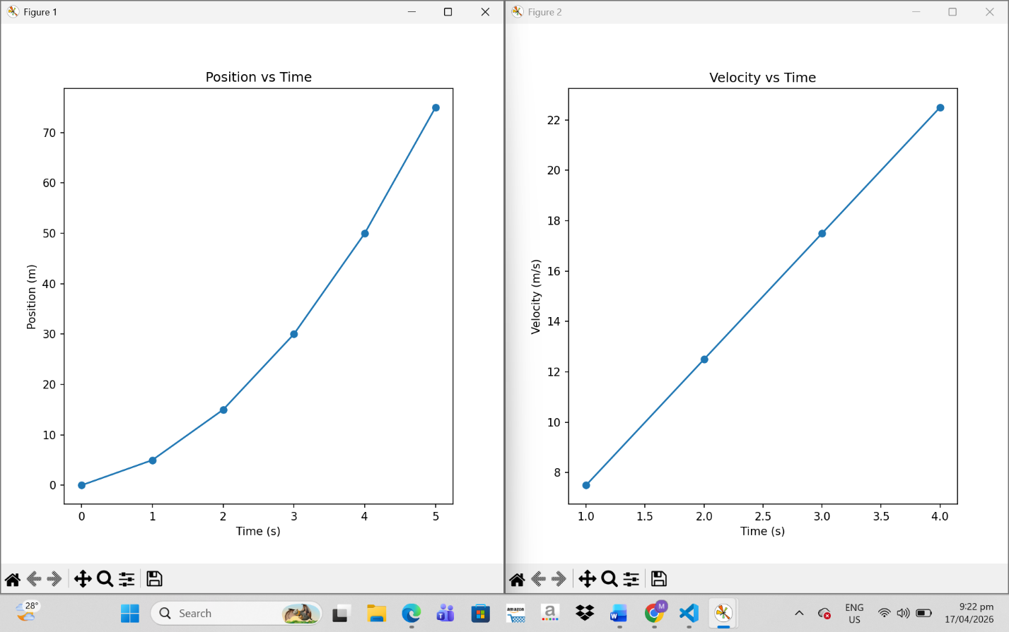
- Position vs time

- Curve is nonlinear (parabolic-like)
- Indicates acceleration

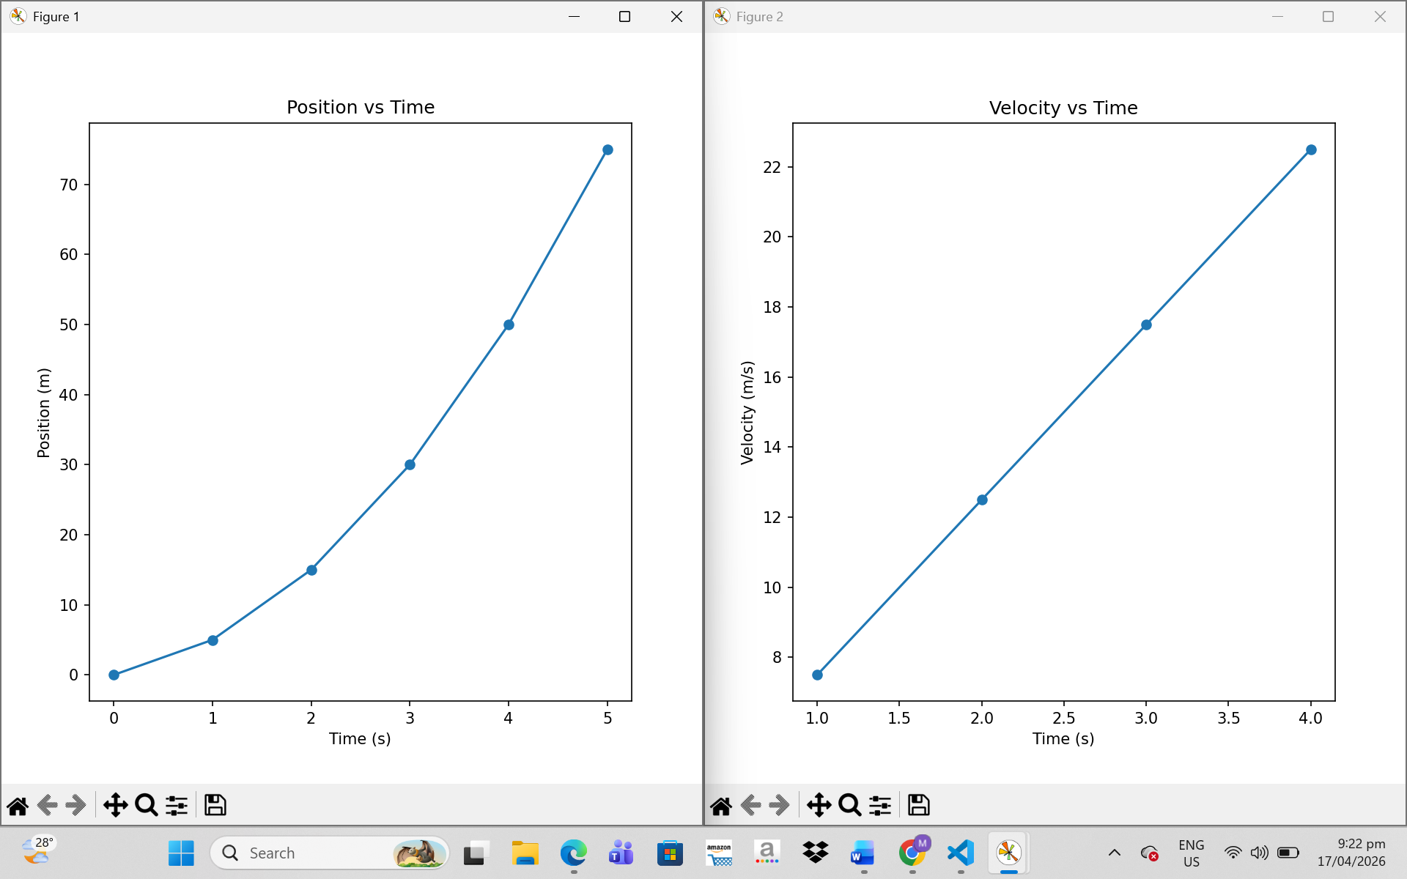
- Velocity vs time

- Straight line increasing
- Confirms constant acceleration

- Analysis Questions
- When is the car accelerating?
- The car is accelerating at all times (from t = 0 to t = 5 seconds).
- Velocity is increasing continuously
- Is motion uniform?
- The motion is not uniform because velocity is changing every seconds (7.5 – 12.5 – 17.5 – 22.5)
- It is uniformly accelerated motion because velocity increases by equal steps and acceleration is constant.
- Identify any anomalies (sudden jumps)
- No sudden jumps
- Data is smooth and consistent since there are no sudden drops, irregular spikes, and no missing or inconsistent values.

The vehicle shows uniformly accelerated motion. Using central difference, velocity increases steadily from 7.5 m/s to 22.5 m/s. Acceleration is constant at 5 m/s², confirming uniform acceleration. Trapezoidal integration of velocity gives a total displacement of 75 meters, which matches the final recorded position. This shows that the data is consistent and represents smooth, non-anomalous traffic flow.

